Spotify Online Music Streaming Service

Organization Description:

A Swedish advertisement streaming and media services provider, turned to the world’s largest music streaming service provided, Spotify, as of September 2021, has around 400 million monthly active users, including 200 million paying subscribers. With a music library of over 70 million songs, Spotify offers digitally copyrighted restricted recorded music and podcasts. As a [freemium](https://en.wikipedia.org/wiki/Freemium) service, basic features are free with advertisements and limited control, while additional features, such as offline listening and commercial-free listening, are offered via paid subscriptions. Spotify is currently available in 180+ countries as of October 2021. Users can search for music based on artist, album, or genre, and can create, edit, and share [playlists](https://en.wikipedia.org/wiki/Playlist).

User Requirements:

Data to be maintained for below Entities:

1. USER
2. User_ID (Uniquely Identify Users)
3. User_Name (Name of the Users)
4. User Email Id (User Email Id)
5. User Contact No (Contact Number of the user)
6. User Location (Geographical location of the user)
7. User Type (User type – free or premium)

Customer can be either a free user or a premium user, but not both.

For free user’s ad frequency is maintained, and for premium user premium account type is stored. And for premium users a transaction is maintained to store transaction id, date of transaction and user id is stored.

1. ARTIST
2. Artist ID (A unique identifier for artists)
3. Artist Name (Name of the artist)
4. Artist Genre (The music genre the artist produces in)
5. Artist Followers (Number of users that follow that artist)

Artist creates albums and songs. The artist must have at least one song or one album. But one song can have a single artist or multiple artists could have collaborated on any given song or album. A song belongs to certain album or could be a single. An album must have at least one song in it.

1. ALBUM
2. Album Id (A unique identifier for the album)
3. Artist Id (Foreign key referenced from the artist table to link the album and artist)
4. Album Name (Name of the music album)
5. Album Genre (Music type of the album)
6. Album Duration (Total duration of the album in minutes)
7. Album Release Date (The date on which the album was released)
8. Number of Songs (The number of songs in the album)
9. Album Likes (The number of likes by user for that album)
10. SONGS
11. Song ID (A unique identifier for the song)
12. Album ID (Foreign key referenced from the artist table to link the song and album)
13. Artist ID (Foreign key referenced from the artist table to link the album and artist)
14. Song Name (Name of the song)
15. Song Genre (Genre/Music type of the song)
16. Song Duration (Time duration of song in Minutes)
17. Song Release Date (The date on which the song was released)
18. Song Stream (Number of streams/listens to the song)
19. Song Likes (Number of likes given to the songs by listeners)
20. USER ACTIVITY
21. User ID
22. Song ID

User Activity Table stores the listening activity of the users. It stores the User ID and song ID to show which user listened to which songs.

1. Transaction table

This table maintains transactions of users

a.Tran_Id(Primary key)

b. User_id(Foreign key which references to user table)

1. Free Account

This table contains information of Trial version users

1. User_id(foreign key that references to users table)
2. Ad_freq(how frequent does the user see an advertisement)
3. Duration(how long the user has been a spotify user)
4. Premium Account

This table contains information of Premium subscribers.

a.user_id(foreign key that references to users table)

b. premium_type(Is it a quarterly or an yearly plan)

ENTITY-RELATIONSHIP DIAGRAM

ENHANCED ENTITY RELATIONSHIP MODEL

RELATIONAL DATABASE MODEL

1. DDL

Created 8 tables based on RDB

1. Alter table

b)Drop table

c)Rename



1. DML
2. Select

1. Insert

1. Update

d)Delete

1. Queries
2. Nested Query

b)Inner Join

c)Equi Join

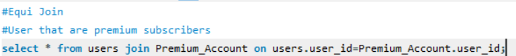



d)Natural Join

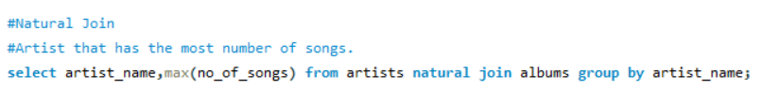

e)Left join

1. Views

